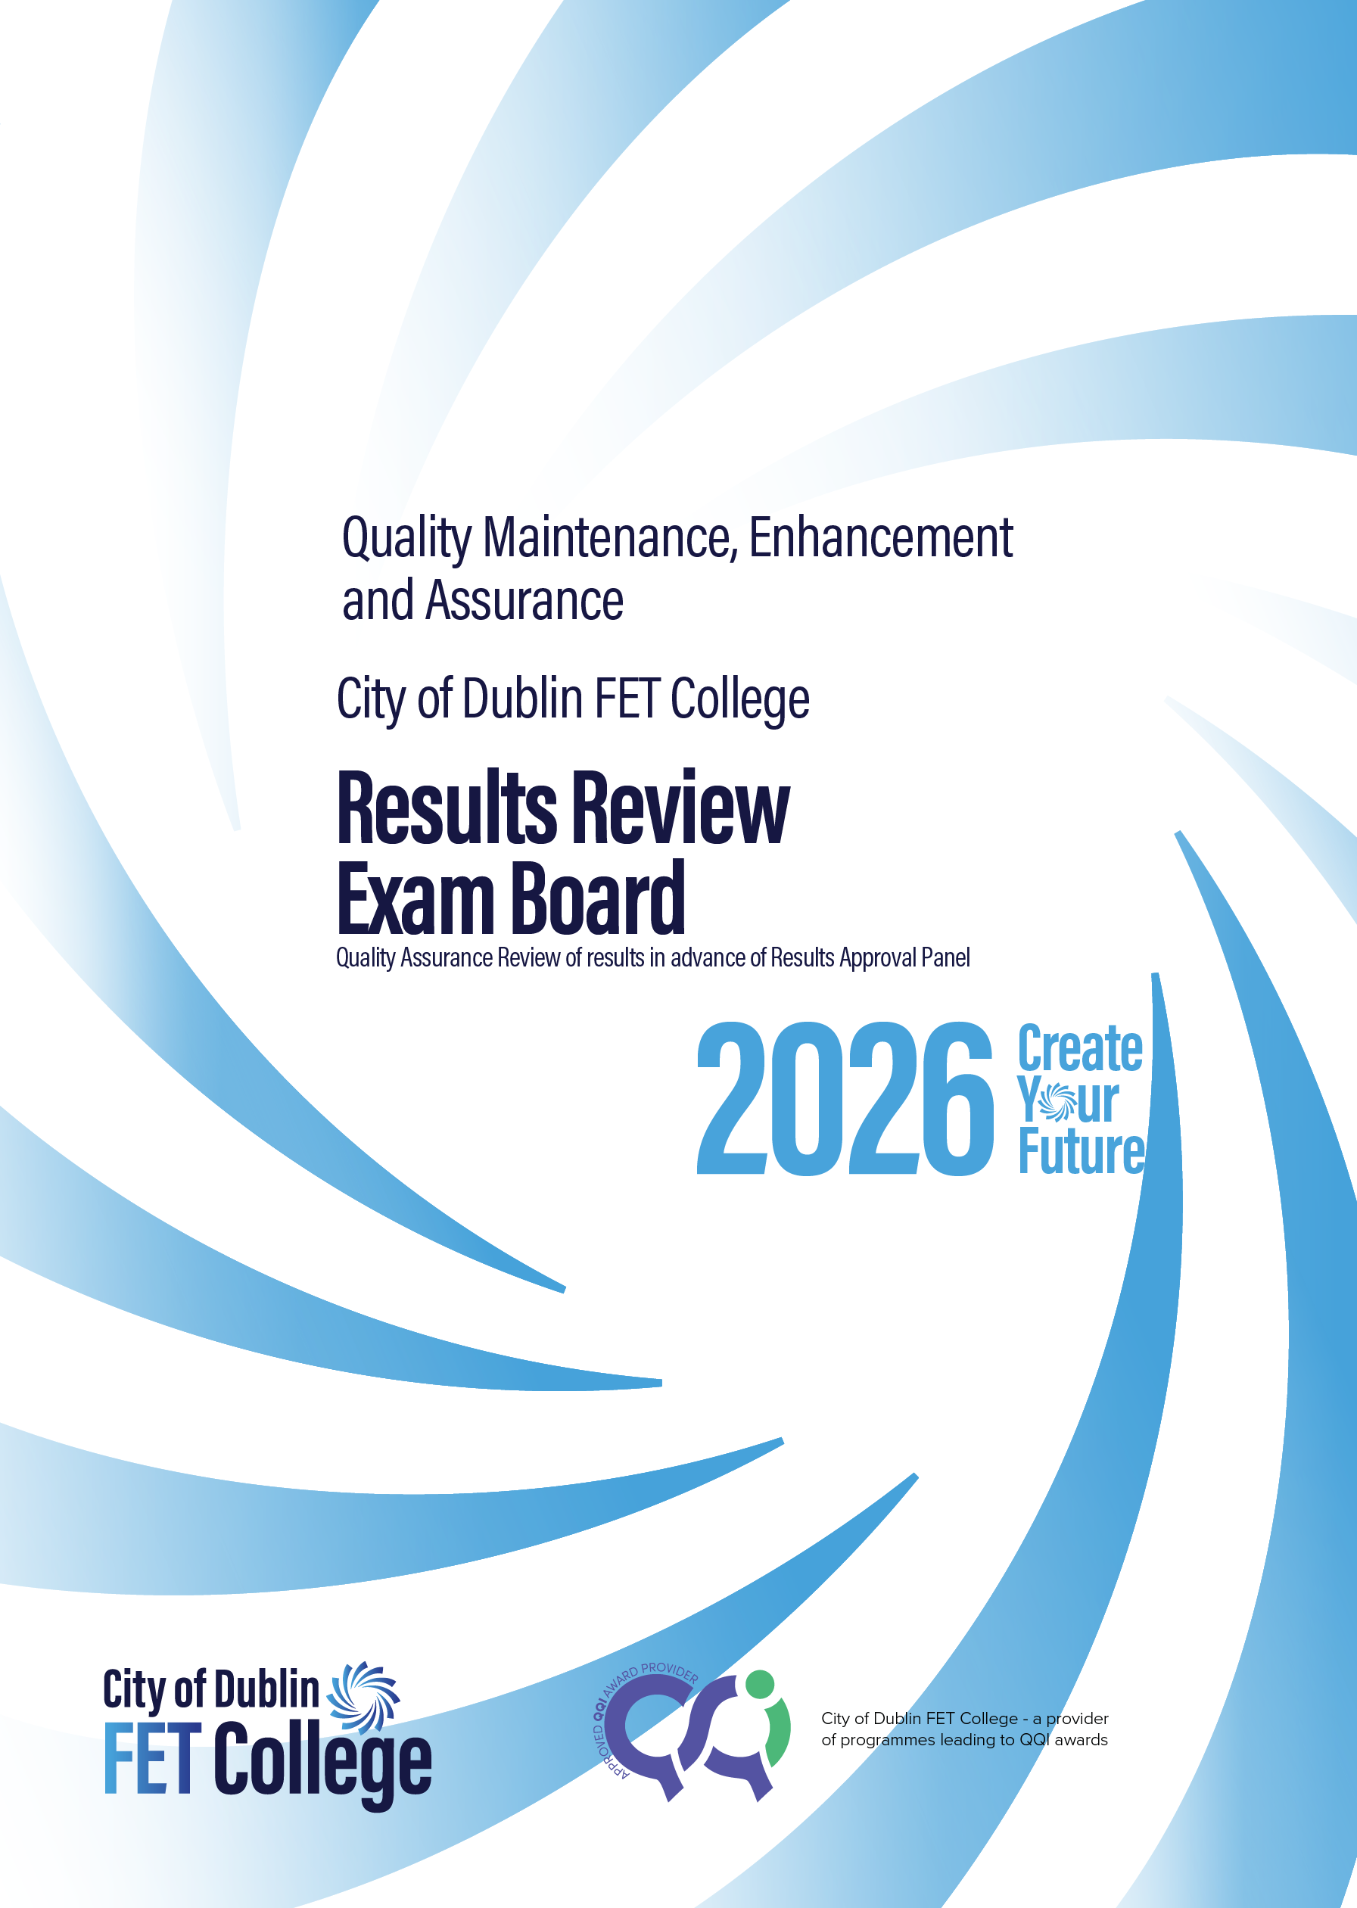
V.3 February 2026

Contents
Quality Improvement Processes in City of Dublin FET College 3
Exam Board 4
Who attends the exam board 4
Role of Exam Board 4
Examination of Learner Results 4
Immediately following the Results Exam Board 4
Exam board Agenda 6
Exam board report 7
Glossary of terms 9

Quality Improvement Processes in City of Dublin FET College
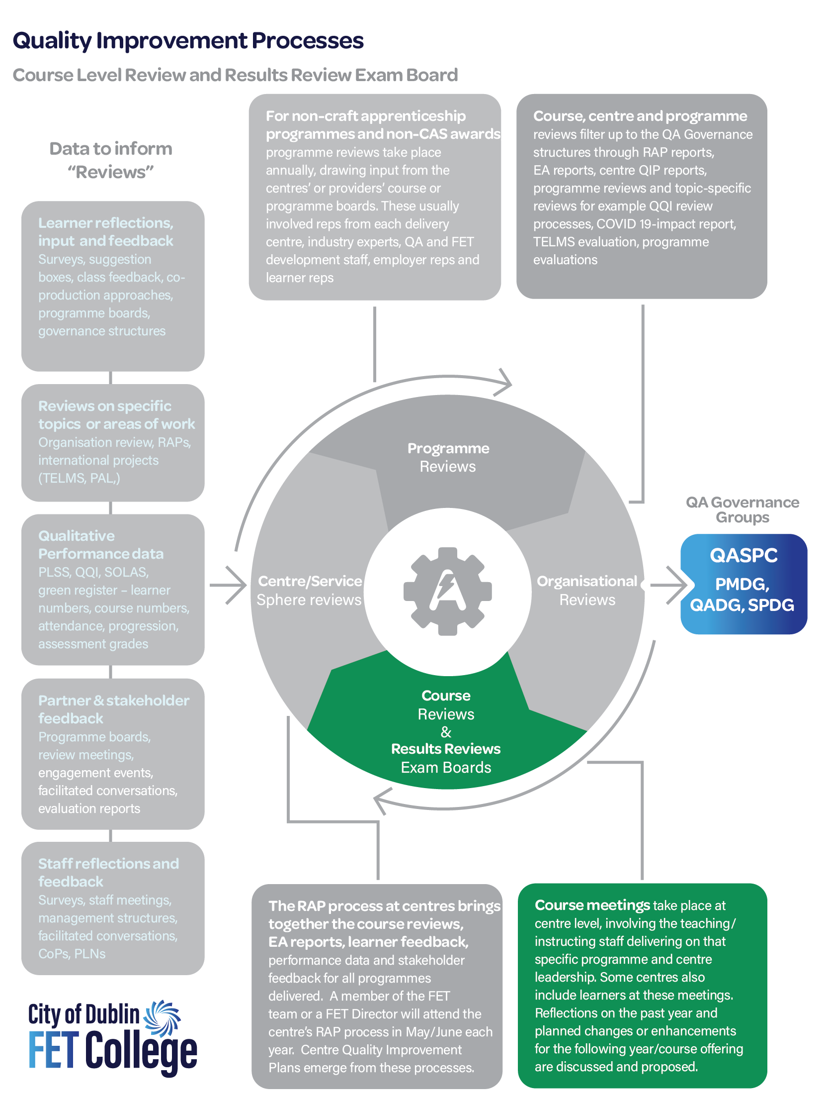

V3 Updated February 2026

Exam Board

Who attends the exam board
- The educators/assessors of all modules on the course
- Chairperson – nominated by Principal
- Note taker – nominated by Chairperson

Role of Exam Board
- To review all learner results across the full course
- To make grade change recommendations to the Results Approval Panel (RAP) based on anomalies identified as part of IV processes, mitigating/extenuating circumstances or borderline grades.
- To ensure Minimum Intended Module Learning Outcomes (MIMLO’s) / Learning Outcomes (LO) are achieved
- To identify quality improvement opportunities for inclusion in the Centre/Service Sphere Quality Improvement Plan (QIP)

Documents to be available at Exam boards
- Copy of learner results
- MIMLO tracking documentation for each module
- IV report
- EA reports – where available
- Documentation from learners or staff to support extenuating circumstances

Examination of Learner Results
It is important that educators are open to reviewing the totality of the learners’ work, to include the achievement of Minimum Intended Module Learning Outcomes (MIMLO) across two or more modules, integration of assessments and any mitigating/extenuating circumstances. The following points should be borne in mind by the Exam Board.
- Where grading anomalies or borderline grades appear, they should be reviewed, and a decision made by the Exam board on grade outcomes. Decisions should be taken regarding learners’ grade after all the information that would have a bearing on their grades has been presented. This includes achievement of Learning Outcomes (LO)/ MIMLOs across two or more modules, integration of assessments, mitigating or extenuating circumstances.
    - There should be a clear record of the grade change in the minutes of the meeting and the rationale for the change

- Where a learner has achieved 50% or more in a module but has not completed the required assignments to evidence of achievement of the MIMLOs, this evidence should be sought across the full award.
  - There should be a clear record of the achievement of the MIMLO in the minutes including the module / assignment that the learner demonstrated the achievement in
All sensitive material and learner records should be handled with care, learner personal data should be securely archived.
Arrangements for repeats or resubmissions of assignments, where relevant should be agreed; It is important that relevant learners should be informed and equipped with repeat assessment and dates to submit/re-sit exams at the time of issuing the provisional grades.

Immediately following the Results Exam Board
- The Exam board Report should be prepared for the RAP meeting, it should
- Recommend the results for the learners and in the case of grade changes or achievement of the MIMLOs across the two or more modules it should outline how the recommendation was reached
- Identify any Quality Improvement Plan (QIP) actions that should be considered by the centre to inform the centre or service spheres’ QIP
Learner results should be updated on all systems (internal and external awarding body systems e.g: QBS for QQI awards) and in records within the centre and online awarding body systems.

Repeats: Educators and learners will need to be informed of repeat exam or repeat assessment which relates to their module.


Exam board Agenda
Exam board Agenda
Course Title & Class Code:
Programme Title and Code:
Date | Time | Venue of Meeting | Attendees

Welcome
- Chair welcomes everyone, introduces membership and notes any apologies
- Chair appoints a secretary/record taker
- Any potential conflicts of interest are noted

Results Review
1. Review and check that results are accurately transferred to the awards system (E.G: QBS)
2. Review and check the learner groups set of results
3. Identify any issues and correct
4. Recommendations
- Achievement of MIMLOs across 2 or more modules
- Borderline grade changes
- Grade changes (IV, mitigating circumstances, appeals, anomalies )
- Progression recommendations
- Repeats – exams / assignments (see City of Dublin ETB repeats Policy)

Proposed Programme modifications and actions for the QIP

- Programme modifications – is there changes needed to the module descriptors for across City of Dublin FET College – for 28 updated modules for all other modules
- Quality improvement actions to be considered for the center or service spheres QIP

Closing
Thank all staff for their participation. All documents are returned to the Chairperson or if online documents are deleted at close of meeting – care to be taken when handling sensitive data.

Exam board report

Exam board Report
(for submission to Results Approval Panel (RAP))
Course title and code |  |  |  |  | Review date:
Programme title and code |  |  |  |  | Starting numbers |  |  |  | Finishing numbers
Chairperson |  |  |  | Record taker
In attendance
Apologies
Areas for discussion or action  - Achievement of MIMLOs across 2 or more modules  - Borderline grade changes  - Grade changes (IV, mitigating circumstances, appeals, anomalies)  - Progression recommendations  - Repeats – exams / assignments QIP actions for this course to be reported to centre-level / RAP review. |  |  |  |  |  | þ Actions to be completed following meeting.
 |  |  |  |  |  | ​​☐​ Grades Amended ​
 |  |  |  |  |  | ​​☐​ Repeats – exams / assignments
 |  |  |  |  |  | ​​☐​ QBS/result record corrections
 |  |  |  |  |  | ​​☐​ QIP actions identified
 |  |  |  |  |  | ​​☐​ Progression notification on PLSS
 |  |  |  |  |  | ​​☐​ Other
Balanced appraisal of the course results looking at these areas – insert comments and expand text box as required
Overview of Results
Proposed MIMLO modifications recommended achievement of MIMLOs across 2 or more modules | (Insert or attach learner names and modules/assignments where MIMLO achievement was demonstrated)
Proposed grade modifications recommended changes and rationale for change | (Insert or attach learner names and modules/assignments where grade was modified and outline rationale for change)
Progression recommendations recommend progression of learners within FET (priority offering) | (Where there is a progression option within FET for this learner group please note if learners can be progressed)
Repeat – exams / assignments details | Insert repeat arrangements and follow up actions required
Learner progression | ​​☐​ Employment | ​​☐​ Further/Higher Education |  |  |  |  |  | ​​☐​ Other

The Exam board agree to this set of results | ​​​

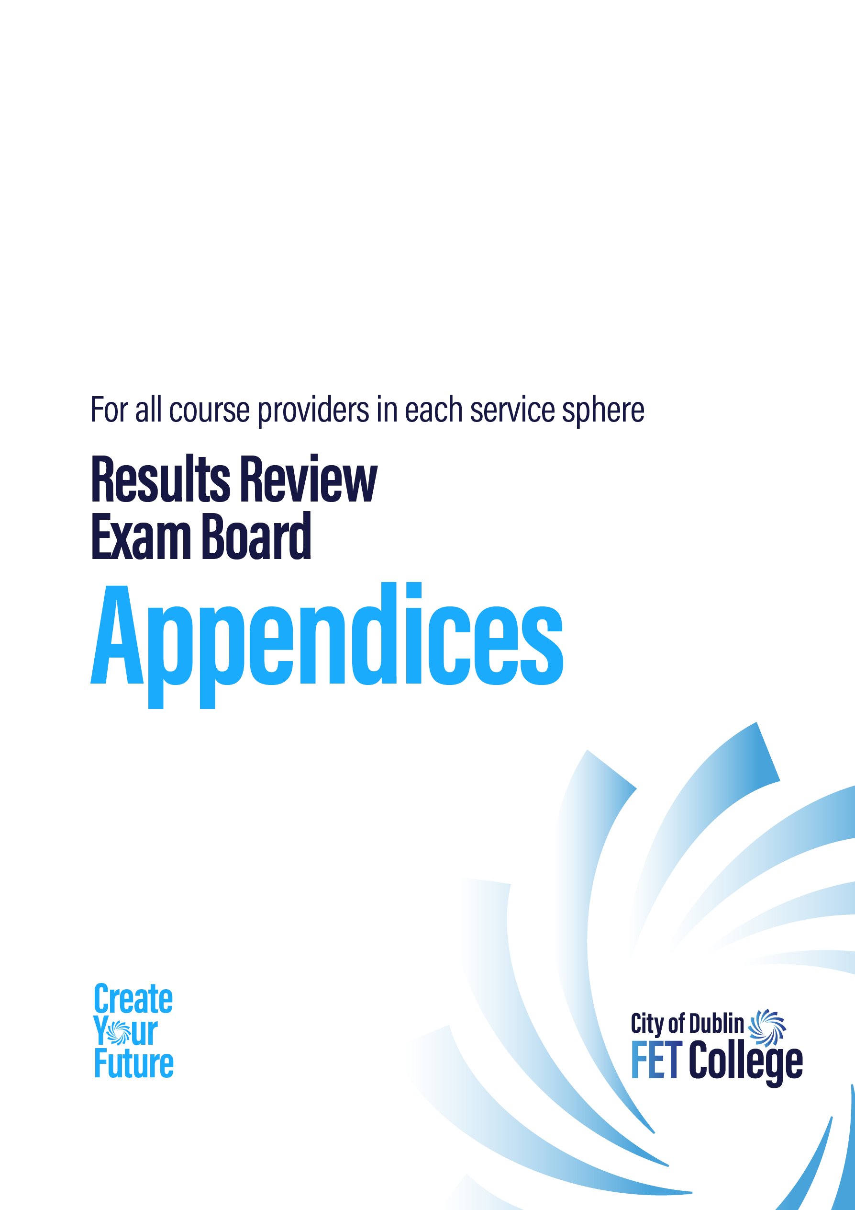

Glossary of terms
Centre
Learner | Refers to learners/students/participants/trainees/apprentices, who attend and participate in courses provided and delivered by City of Dublin FET College.
Educator | Refers to teachers/instructors/tutors/trainers – this may also refer to any staff who manage, lead or coordinate a course in a centre
Principal/Manager | Senior level management in a centre.
Service Sphere | City of Dublin FET College have 5 Service Spheres: Youthreach, Adult Education Service, Education Service to Prisons, Training Centres and Colleges of Further Education
Quality Team | All City of Dublin FET College centres or service spheres have a Quality Team which is the local quality governance team responsible for overseeing and ensuring quality within their centre/college or service
Course Team | The Educators, work-based assessors and support staff involved in delivering the course within the centre to input manage the delivery at course level, programme and results review exam board reviews.
Organisation/Institution | This refers to City of Dublin FET College organisation wide and as Provider of FET programmes.
SMART | Specific, Measurable, Achievable, Relevant and Time bound goals or objectives
Award
Awarding body | Organisations who certify awards delivered in a centres e.g: QQI
QQI | Quality and Qualifications Ireland is an independent State agency responsible for promoting quality and accountability in education and training services in Ireland.  It was established in 2012 by the Qualifications and Quality Assurance  (Education and Training) Act 2012 (link to Act). See about QQI at this Link QQI are also an awarding body
QQI Award | A QQI Award is a quality-assured qualification awarded by QQI. City of Dublin FET College have validated programmes and modules that are QQI awarded.
CAS Award | Common Awards System – made by QQI at NFQ Levels 1 to 6
Course
Course |  | A course is derived from a validated programme. A programme can give rise to a number of different course depending on the module selection. It is a collection of modules with an overall objective, when successfully completed and combined will result in a qualification
Programme |  | The City of Dublin FET College validated programme that iterations of courses are taken from. It can also refer to a course by non QQI awarding bodies.
Assessment |  | The process of evaluating the learning outcomes of a programme to enable grading.
Grade or Result |  | A Grade/Result is a level of achievement attainment by the learner.
CPD or PLD |  | Continuous Professional Development (CPD) or Professional Learning  Development (PLD) – Access to PD videos for staff are found on the CDU Moodle site. The PLD calendar is circulated to all centres and staff to access upskilling.
Internal Verification |  | Centre Quality Assurance checking of assessment evidence prior to External Examiner Centre visits.  Each Awarding body has its own internal & external verification requirements.
External Authenticator or External Examiner |  | Quality Assurance independent assessors who check the National Standard of assessment is delivered and maintained in line with the Awards. E.G. External Authenticators – QQI
SLT |  | City of Dublin FET College Senior Leadership Team (SLT) is composed of five Directors and Chief Executive with responsibility for further education and training.
FET Development Unit |  | City of Dublin FET College unit tasked with providing support in the area of Quality Assurance in Further Education and Training.
Learner Support and  Enhancement Service (LSES) |  | Established in 2022 to support City of Dublin FET College centres to provide a high-quality learning experience for all; sharing of practice, a collaborative development of policies, resources and toolkits. Learner LSES SharePoint site College Connect - Home
Quality Maintenance, Enhancement and Assurance  Quality Assurance |  | The term “quality assurance” describes “the processes that seek to ensure that the Learning environment (including teaching and research) reaches an acceptable threshold of quality. QA is also used to describe the enhancement of education provision and the standards attained by learners. UNESCO defines quality assurance (QA) as “…an ongoing, continuous process of evaluating (assessing, monitoring, guaranteeing, maintaining and improving) the quality of ... [an] education system, institution or program.
 | Course-level review | Detailed review of the learner journey experience of a course/programme in a centre at the end of the programme cycle. This includes examination of learner/stakeholder feedback, learner results/outcome data and previous years reports with a view to identifying areas of good practice and areas for improvement.
 | Centre-level/service sphere-level review | Detailed review of the learner journey experience annually within the centre, which will include examination of the outputs of course reviews, external examiner reports and relevant data with a view to identifying areas of good practice and areas for improvement. This will include the sign-off of results for a centre (QQI required activity).
 | Results Approval Panel  (RAP) | Centre quality check conducted at the end of an assessment period. Centre signs off on results to proceed to submit to Awarding body. Takes place prior to every certification period (6 times per year for QQI)
 | Quality improvement plans (QIP) | Quality Improvement Plans are required by every centre and service sphere to inform the priorities of City of Dublin ETBs organisational QIP which is submitted annually to QQI and Published on the City of Dublin ETB website for public viewing. The QIP sets out the planned priorities for the organisation to address.
 | Organisational | Refers to City of Dublin ETB and all its centres and services
 | Thematic reviews | Thematic Reviews are specific topics that City of Dublin ETB may gather information from across its centres and services, informing quality improvements.
 | Showcase of Best practice | A City of Dublin FET College collaborative quality initiate to foster sharing of ideas and solutions tested on the ground by centres.
 | City of Dublin FET College Governance (Corporate Level QA)
 | Quality Assurance and Strategic Planning Council (QASPC) | responsible for overseeing and making recommendations on quality maintenance, enhancement and assurance and strategic planning at City of Dublin ETB Quality assurance level.
 | Programme Management and Development Group (PMDG) | QA Governance group PMDG, responsible for overseeing the management and development of programmes at ETB level.
 | Quality Assurance and Development Group (QADG) | QA Governance group QADG, responsible for the quality assurance developments and enhancements for City of Dublin ETB.



