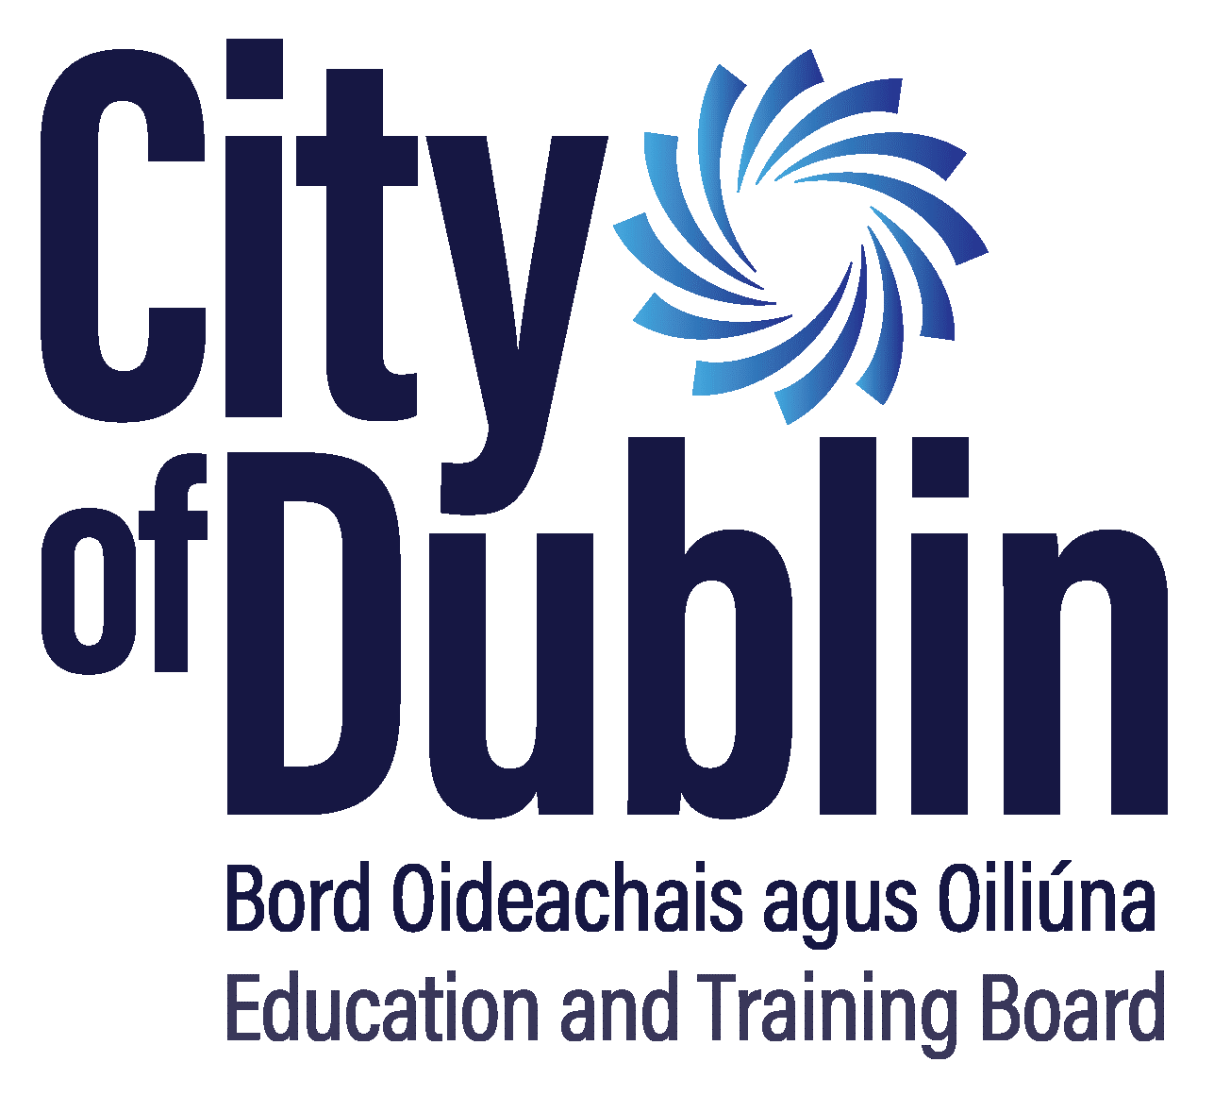
Insurance Indemnity Declaration Form

Indemnity Declaration Form for use of personal motor vehicle on official business authorised by City of Dublin Education and Training Board

To be completed by all staff employed in Education and Training Boards, Board of Management Members and other persons conducting official business on behalf of the Education and Training Board.

I acknowledge that the authority given to me by the Education and Training Board, to use my own motor vehicle (details of nominated vehicle___________________) on official business, is subject to any relevant regulations or conditions in force from time to time and, in particular, to the condition that it is insured, and will continue to be insured, by me for the purpose of the Road Traffic Act 1961.

I have duly informed my conventional motor insurer of such business use and this reflected in my motor insurance policy.

It is at present insured with ___________________________________ and I undertake to notify the Education and Training Board of any change.

I am aware that neither the Education and Training Board, the Department of Education and Skills, nor the State, will accept liability for any loss or damage resulting from the use of my motor vehicle on official business, including professional development.

I further confirm that I am not prohibited from driving due to any legal constraints imposed by the judicial system.

Signed: _____________________________________

Print Name: _____________________________________

Position: _____________________________________

Staff No: ___________________ Centre: ____________________

Date: _____________________________________

This completed Indemnity Declaration Form should be returned to City of Dublin Education and Training Board

