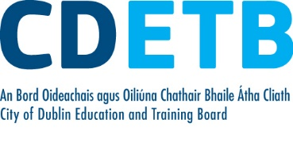
Blended Learning Policy

- Principles, Aims and Scope of Policy

The following Policy Principles will be applied:
- Quality provision
- Inclusion
- Trust
- Autonomy
- Respect
- Empowerment

The following are the key aims of the policy:
- To use TEL tools to enhance teaching and learning
- To use blended programme delivery to create greater levels of access to FET programmes
- To improve service quality and programme outcomes for learners
The current scope of this policy is to incorporate blended e-learning learning opportunities in a manner that complements both the CDETB and the college’s quality assurance procedures.
- Policy and Procedure Overview
This overarching CDETB Blended Learning Policy:
- defines TEL/Blended Learning/Blended Programme Delivery for the organisation –
- Sets out what requires corporate approval and what doesn’t
- provides overview of the procedures that apply to facilitate a move to a blended delivery mode for FET programmes, which involves distance learning (remote delivery)

- Technology Enhanced Learning (TEL)

TEL can be succinctly described as any practice that involves ‘using technology to facilitate and support innovative teaching and learning’.The potential for technology in education is immense. Complex theories, concepts and subject matter can be illuminated using simulated and virtual worlds. The use of technology can allow people to decide when and where they learn. It can also facilitate high-quality, individualised feedback between teachers and learners, interactive learning with online learning groups and support communities of practice.

Using such technology correctly and appropriately requires consideration and planning. It is essential that such technology is used to the benefit of the learner, to ensure and enhance high quality programme delivery while also maintaining the integrity of learning and learner achievement. This requires the necessary technology infrastructure, knowledge and supports are in place.

Technology does not achieve quality in and of itself, it is therefore important in the interests of the learner that when and how it is used is quality assured, as required in all other aspects of education and training programme delivery. Technology can be used at any point of the learner journey on a programme of education and training ‘to enhance learning on initial engagement, as part of course delivery and assessment, and in supporting career progression’.

Regardless of when it is used as part of programme delivery there are four key elements; Technology Infrastructure, Programme Design, Programme Content and Continuous Professional Development as illustrated in Figure 1 below. The Continuous Professional Development element can also be taken to apply to learners as they will also require training and support to effectively use the technology.

Figure 1Four Elements of Technology Enhanced Learning

CONTINUOUS PROFESSIONAL DEVELOPMENT

LEARNING CONTENT

PROGRAMME DESIGN

TECHNOLOGY INFRASTRUCTURE
TECHNOLOGY ENHANCED LEARNING IN FURTHER EDUCATION AND TRAINING

- CDETB TEL Strategy
CDETB is the statutory provider of programmes of further education and training in Dublin City. CDETB recognises the important role technology has to play in supporting innovation in programme delivery and widening access to its programmes; and this is reflected in the policy aims and strategic approaches as set out in our Education, Training and Youth Services Strategy 2015-2020, as follows:
to promote and support education and training innovation, creativity and change” and to support the achievement of this goal the following strategic approaches were identified by CDETB
- promote flexible learning opportunities (e.g. online, blended, semesterised and evening provision)
- support the development and implementation of E-learning in our schools/colleges/centres

TEL has an important role to play in terms of supporting active inclusion for vulnerable groups of learners and providing greater levels of access to FET programmes in general is also mirrored in the SOLAS FET Strategy (2013-2019) with blended and distance learning identified as key tools in achieving the follow key strategic aim:
to ensure equality of opportunity and access to FET and equal treatment of learners by identifying strategies to address psychological, social and economic barriers to participation of groups experiencing socio-economic exclusion/distance from the labour market.
An evaluation of Post Leaving Cert (PLC) programme provision conducted by the Economic and Social Research Institute (ESRI) recommends that providers of PLC programmes should also be required to offer more flexibility to learners by offering these programmes in non-traditional ways e.g. via online platforms. CDETB has devised a specific Technology Enhanced Learning (TEL) Strategy entitled CDETB Enhancing Teaching, Learning and Assessment through Technology Strategy 2018 – 2023. This strategy is also in line with the national strategy for the FET sector as devised by Solas, which in turn supports and complements the ICT Strategy 2016 developed by ETBs; the 2013 National Digital Strategy for Ireland; the 2015 Public Service ICT Strategy; the overarching Further Education and Training (FET) Strategy 2014–2019; the National Skills Strategy 2025; the 2015 Digital Strategy for Schools; and the Digital Roadmap for Higher Education.
The key aim of the CDETB TEL Strategy is to ‘enhance Teaching, Learning and Assessment through Technology in our second level schools, Colleges of Further Education, Youthreach centres, Prison Education service, Training Centres and the Adult Education Service’.
‘CDETB will use digital technologies to enhance teaching, learning and assessment so that our learners will become engaged thinkers, active learners and knowledge creators to participate in enterprise, the economy and wider society’.
To increase the uptake of TEL across the CDETB there are a number of corporate level initiatives and processes being pursued as part of the TEL strategy to create baselines, build on existing good practice and capacity, expand access and lead to continuous improvement supported by a community of practice with a positive culture of embracing and employing TEL. Figure 2 below is a useful illustration
To assist innovation and the development of policies and procedures in this area CDETB supported a number of research and development initiatives as part of its TEL strategy including the Technology Enhanced Learning Mentoring Support (TELMS) project and the Blend4VETproject. These projects were designed to develop capacity and capability amongst centres and teaching staff to use TEL tools in the classroom –TELMS, and to offer more flexible blended programmes – Blend4VET.
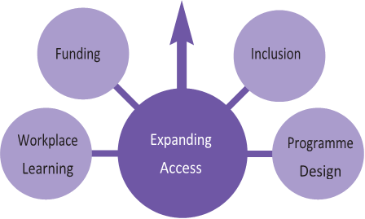
Continuous Professional Development
Technology
Structure
Building on existing capacity and good practice
Content
Culture
Community
of
Practice
Good
Practice
Continuous
Improvement and innovation
Evaluation
Figure 2 Associated Themes and Actions

- QQI QA Guidelines on Blended Learning
QQI have developed Topic Specific Statutory QA Guidelines on Blended Learning. They supplement QQI Core & ETB Sector-Specific QA guidelines and the QQI Validation Policy, and apply to the provider, and therefore all their programmes of education and training not just programmes leading to QQI awards.

Figure 3 QQI Statutory QA Guidelines
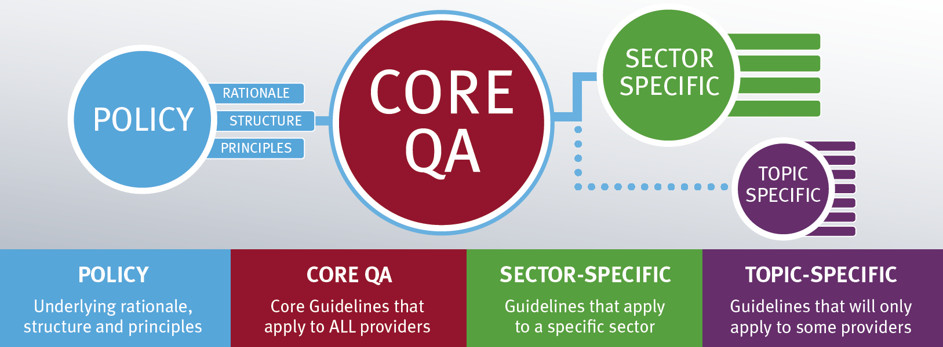

Providers are required to develop QA policies and procedures and the QA guidelines provide guidance on what should be considered to inform the development of a provider’s QA procedures. Providers must have effective QA procedures, and it is the role of QQI to monitor the effectiveness of a providers’ QA procedures.
CDETB as a statutory providers must assess the capacity its centers to deliver CDETB programmes. The ability of center to deliver a blended programme also comes within this requirement. The QA Guidelines on Blended Learning are directed towards this. The guidelines have the following features:
Figure 4 Key Features of QQI QA Guidelines on Blended Learning
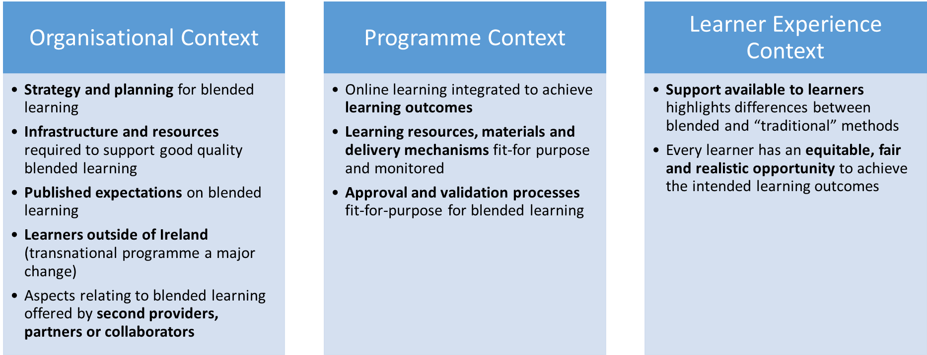
TEL and Blended Learning
Blended learning is a type of TEL initiative. The degree to which technology can be used in a programme of education and training can vary. It is important to understand the use of TEL as part of blended learning in FET programmes can be represented on a continuum:
‘moving from the traditional classroom-based/face-to-face learning, supported by technology, to a more flexible, blended approach which makes significant use of technology and reduces face-to-face contact, on to a fully online approach which is entirely dependent on technology’
TEL can be used to facilitate blended learning to include:
- Using TEL tools in the classroom
- Using the Virtual Learning Environment (VLE) to complement and supplement face-to-face delivery
- Using the VLE to partially replace face-to-face delivery – this brings in the element of distance learning, allowing learners to complete in their own time within a prescribed period.
This can also be seen a weak to strong blend approach, with fully face-to-face or fully online not being a blend at all. This is recognised by QQI in the statutory QA Guidelines on Blended Learning. QQI cite Garrison and Kanuka (2004) who define blended learning as “the integration of classroom face-to-face learning experiences with online learning experiences”
However, QQI are clear that their statutory QA guidelines on blended learning ‘are constructed to support blended learning programmes; typically these are face-to-face programmes which incorporate remote online learning via a virtual learning environment’. In other words, where there is a VLE being used to deliver part of the programme remotely (distance learning) amounting to a blended mode of delivery for the programme.
The further on the continuum a TEL initiative is, the more thought and planning and resources will be required for each of the four elements of; technology infrastructure, programme design, programme content and continuous professional development to ensure it is successful and a quality assured service is provided to learners.
This is where there is a distinction to be made between a teacher/trainer/tutor using a blended teaching methodology versus using a blended mode of programme delivery. The former involves using the Virtual Learning Environment (VLE) and TEL tools to complement and enhance face-to-face delivery (teaching in the classroom). The latter involves using the VLE and TEL tools to actually replace face-to-face delivery, for remote delivery (distance learning) thereby reducing the need for face-to-face contact time and creating more flexibility for the learner in terms of when and where they complete these aspects of the programme in the VLE.

- Learner Effort and Blended Learning

FET progammes have a credit value which reflect the required amount of learner effort. FET credit is quantified in multiples of 5 FET credits (up to 50 hours of learner effort). Learner effort is based on the time taken by typical learners at the level of the award to achieve the learning outcomes for the award. It includes all learning time involved including: guided learning hours, self-directed learning and assessment. (QQI). 1 FET Credit is up to 10 hours.

Directed Hours:
Directed hours are the hours the provider spends directly delivering the content of the programme to the learner. They include class contact, direct online contact, assessment and laboratory time. They can include work-based direction, where there is a tutor and or instructor on-site delivering content.

Self-Directed Hours
Self-directed hours are the hours where the learning is learner-lead. They include practice time, work experience, preparation, study time and reflection time.

Structured on-line reading/activities/formative assessments that are required to be completed (mandatory on-line contact time) as part of the programme in lieu of face to face contact and are subject to monitoring (e-moderation) by a teacher/trainer are directed study.

Where a teacher/trainer provides additional resources to learners via an on-line and learners can avail of them as additional study and reading are considered to be self-directed study, which is learner led and can be pursued at any time.

The following are the required bands of learner-effort and the hours required for directed and non-directed study for FET programmes:

Major Awards
Level | Major Award Credits | Typical Learner Effort in Hours | Programme Directed Hours  Range | Programme Self-directed Hours  Range
L 1 | 20 | 200 | 150-200 | 0-50hours
L 2 | 30 | 300 | 250-300 | 0-50 hours
L 3 | 60 | 600 | 300-550 | 50-300
L 4 | 90 | 900 | 400-800 | 100-500
L 5 | 120 | 1200 | 500-1000 | 200-700
L 6 | 120 | 1200 | 500-1000 | 200-700

Special Purpose, Supplemental and Minor Awards
Levels 1-6 | Credit Values | Typical Learner Effort in hours | Programme Directed Range | Programme Self-directed Range
 | 5 | 50 | 15-50 | 0-35
 | 10 | 100 | 30-100 | 0-70
 | 15 | 150 | 50-130 | 20-100
 | 20 | 200 | 80-160 | 40-120
 | 30 | 300 | 100-260 | 40-200

- CDETB - Quality Assurance Approach to move to Blended Mode of Programme Delivery
From a quality assurance perspective there are a number of considerations.
CDETB as the provider must ensure that learners achieve at least parity in terms of the quality of service they would receive, were they to complete the programme completely on-.site. It is also part of our quality assurance procedures to review and improve the effectiveness of how we approach our work and ensure the quality of our programmes. To this end, it would be remiss not to examine the potential for enhancing quality through the use of technology.
CDETB, had the opportunity to pilot and partner on a blended programme delivery pilot in 2018/19. CDETB had a centre who wanted to move into blended programme delivery – Marino College of Further Education .The centre had developed capability and capacity through Technology Enhanced Learning Mentoring Support (TELMS) and Blend4VET Erasmus+ projects. We had supportive partners with expertise – FESS, QQI, SOLAS and we needed to develop experience in blended programme delivery, while also ensuring it was quality assured delivery.
CDETB needed an approach to Blended Learning:
- to define policy in the area and the scope of the QA procedures on blended learning
- that supported the conversion of legacy programmes to a blended mode and to support new programme/s development to take in blended learning
- to deal with governance of the area
- to deal with the preparation phase for Centre’s to move into blended delivery
- for delivery of programmes at centre level
- for review, evaluation and updating of policies and procedures in the area
This means we needed an overarching Policy and QA procedures at corporate Level, centre level and a combination of both.
Development Process involved:
- Working together with a lot of consultation and feedback:
- Teachers and Management in Marino College, FESS, CDETB European Projects, External Expertise (H2 Learning) QQI and SOLAS
- Willingness to test things out and see how they worked
- Openness to changing and adapting where necessary – Everyone
- Self-Evaluation Tool developed by FESS with CDETB to help bridge the gap between guidelines and developing procedures – moved from thematic areas in guidelines to a staged model taking in corporate and centre levels.
The following principles were applied in developing policies and procedures:
- Balance to be struck – have sufficient oversight but don’t strangle innovation
- Adapt current processes/procedures to incorporate additional requirements – do not create a totally new processes/procedures/document unless necessary
- Asking for the right information at the right place (within the system) and at the right time (stage of the process)
- Avoid duplication and unnecessary burdens that didn’t add value

The learning gathered from the pilot using the monitoring and review procedures was used to update both the Blended Learning Policy and related procedures.

New Programmes (post 2017):
Where new programmes are being developed by CDETB, and a blended mode of delivery is to be used it will be taken account of at the programme design and development stage. CDETB may choose to develop programmes that can be delivered using both the traditional and blended mode. Centres that wish to develop newly validated blended programme will apply for approval to do so as part of CDETB approval processes i.e. the FETS approval process.

- CDETB Approval - Blended Teaching Methodology versus Blended Mode of Programme Delivery
Blended Teaching Methodology – CDETB Approval not Required – Monitored by the Centre
TEL can be used to support and improve the quality of teaching in the classroom, and also help learners to engage with subject matter while off site and as part of either directed or self-directed study. This is facilitated through a Virtual Learning Environment (VLE) e.g. Moodle.
This is where a teacher/trainer/tutor is using a VLE to complement and enhance face-to-face delivery. Using strategies such as flipped classroom, where reading or an exercise is completed before the class in the VLE, and the learners can then discuss what they didn’t understand with the teacher in the classroom. It can also be used to help the learners reinforce the learning from the classroom; to go back over class handouts, videos of classes taken, extra reading materials, links to a variety of useful teaching and learning resources in different formats, online self-assessment tools etc. Using a VLE can make the time spent in class more effective and meaningful to learners. The VLE becomes a very useful resource and repository of resources for learners especially when completing and preparing for assessments.
Using TEL is this way, facilitated through a VLE platform is using a blended teaching methodology for a module as it is being used to complement and enhance face-to-face delivery. It is not being used to replace face-to-face delivery and reduce face-to-face contact time
This approach does not require corporate level capacity assessment and approval and should be promoted within the centre with teaching/training staff supported to utilise this teaching methodology, and monitored at centre level for quality assurance purposes. Corporate level support may be requested in relation to resourcing infrastructure and organising corporate level CPD initiatives. In this regard, the usual policies and procedures apply. In particular, centres are encouraged to take part in the TELMS initiative. It is an important first step in developing capacity and capability to move to blended programme delivery.

Blended Mode of Programme Delivery – CDETB Approval required
Where a VLE is being used to replace face-to-face delivery – not just complement it. The reduction face-to-face contact time is reduced providing more flexibility to the learner. Using TEL tools including a VLE to deliver programmes partially online, a remote/distance learning fashion, including where summative assessment is conducted online, is considered to be blended programme delivery. If we consider the TEL continuum, the approach being taken is more than just using TEL to enhance delivery in the classroom but does not go so far as to facilitate the offering of a FET programme wholly online. It is for the delivery of some parts of the programme via online (distance learning) where the learners can complete aspects of the programme in their own time, while still having the face to face interaction with the learners at set times. This gives rise to a change in programme mode.
QA Guidelines are mainly focused on blended programme delivery where there is remote/distance learning element. The move to remote delivery in lieu of face-to-face contact brings additional quality assurance considerations which requires with corporate oversight. The remote delivery needs to have underpinning QA procedures.
The physical interaction between learners and the teacher, through lectures, tutorials, seminars, laboratory and practical classes, is important in traditional learning and has therefore been the dominant model in CDETB’s validated programmes to date. While e-learning approaches are growing in popularity, since they provide parallel means of interaction between learners and teachers, a blended solution is preferred as the optimum mode of delivery for these programmes. It is important when moving aspects of a programme into a VLE for delivery, that important elements of the programme are not lost – level of interaction and pastoral care elements. It is important to remember that not all programme are suitable for blended programme delivery.
Where a centre wishes to offer a programme via a blended delivery mode, the centre must apply for approval through the CDETB new course approval process (FETS process). The delivery of CDETB legacy programmes (validated pre-2017) the remote element of on-line delivery is restricted to 30% i.e. the learners must still in the centre 70% of the time for face-to-face delivery. For example where learners were attending 4 days per week, this could be reduced to 3 days. This restriction will be kept under review, however, it should also be noted there are less infrastructural requirements with this restriction in place.

7. Transitioning to Blended Programme Delivery - Quality Assurance Procedures Overview
The procedures take in the following broad stages:
- CDETB Governance Structures - FET Form + approval process – Corporate
- Preparation Stage - Gap/Capacity Analysis and Checklist - Corporate + Centre
- Operational procedures for the Centre – Centre level
- Review and Evaluation Procedures – Corporate and Centre

- Application to change to the mode of delivery for a programme i.e. change to blended delivery will be required.

Centres will apply for approval through the FET Form – this applicant form for approval to deliver a new course has been adapted to take in a change of mode also. Information will be sought to make a decision on whether to approve the centre or not.
Approvals are processed in the following way:
1. All sections of the application form must be completed (where applicable) with full and accurate details in all relevant fields. Insufficient detail in the application may render it void for processing.
2. Applications received will be collated and a list will be circulated to all centres to give feedback. Feedback will be communicated to the relevant applicant centres.
3. Applications along with feedback (where applicable)) will be provided to FET QASPC Sub Committee Working Group, who are consulted on applications.
4. The FET Director will consider all contributions and make a decision on each application.
5. Decisions of Approved/Declined Applications will be communicated to All Principals/ Heads of Centre.
6. Decisions can be appealed to the Chief Executive, up to five days from issue of decisions from FET Director to all centres. A letter of Appeal address the Chief Executive should set out the grounds for the appeal which include:
i. Fair procedures were not applied
ii. The application of the criteria for making the decision was not applied correctly.

- Decisions: an application to convert a programme to blended delivery will be decided against the following criteria:
In addition to the criteria applied for new courses, where the proposed mode of a new course or there is a request to change an existing course to blended delivery, which would involve remote programme delivery, decision will be made with reference to the following criteria:
- Whether sufficient information has been provided to consider the request – all relevant sections must be completed including additional resources and costing
- The suitability of the course and modules proposed for blended delivery to include but not limited to award level, learner profile, vocational area and demand
- The benefit of the mode change to blended learning to the learners
- Extent of course to move to blended (it must not be more than 30% until the programme will be developed and subject to a validation application with QQI). This criterion will be reviewed as capacity is built up within the system, including I.T support.
- The capacity and capability of the centre to deliver via blended learning
- The degree of consistency with the strategic aims of CDETB
- Agreement to engage in CDETB preparation stage
In considering the above, CDETB may seek expert external advice as part of assessing applications for approval. A new course may be approved and restricted to the traditional delivery mode
Conditions of Approval: Preliminary approval may be given under the new course approval process, however, final approval to move to a blended mode of programme delivery does not occur until the preparation stage is successfully completed. The review and evaluation procedures are conducted by CDETB and the relevant centres.
- Preparation Stage. The following must occur as part of the preparation phase:

  - Establishing a TEL Steering Committee
  - VLE and relevant resources in place
  - Member of Management with responsibility for operational side
  - Compliance with legal or statutory obligations appropriate to blended learning contexts be ensured (e.g. child protection, health & safety, equality, intellectual property/copyright, licencing issues, GDPR, PEL, professional or statutory body requirements, local regulatory considerations).
  - Appointing Mentors for every relevant teacher
  - Planning for conversion of modules (for face-to-face and e-learning/remote delivery) and Course Plans with Time-tables for Blended Course
  - Multi-stage Training Plans for Teachers – initial and to introduce new TEL tools during the course in staged manner
  - Multi-stage Induction Plans for Learners – initial and for the introduction of new TEL tools during the course in a staged manner
4. Centre Level Procedures including Monitoring, Review and Evaluation Procedures
The preparation stage, prepares centers to operate the standard operational procedures for blended delivery. These procedures include review and monitoring mechanisms through the centre TEL Steering Committee and may include other CDETB TEL experts and corporate level staff e.g. CDETB TEL Co-ordinator.

Strategy For Technology Enhanced Learning In Further Education And Training 2016–2019, Solas, pg. , available at http://www.solas.ie/SolasPdfLibrary/TEL_Strategy.pdf
Strategy For Technology Enhanced Learning In Further Education And Training 2016–2019, Solas, pg. , available at http://www.solas.ie/SolasPdfLibrary/TEL_Strategy.pdf
Supra, pg
Supra pg
Strategy For Technology Enhanced Learning In Further Education And Training 2016–2019, Solas, pg. , available at http://www.solas.ie/SolasPdfLibrary/TEL_Strategy.pdf
CDETB Education, Training and Youth Services Strategy 2015-2020, 2015, pg , available at: http://cityofdublin.etb.ie/wp-content/uploads/sites/11/2014/05/CDETB-Strategy-2015-2020.pdf
under strategic objective 2.1:
Solas FET Strategy 2013-2019, Strategic Objective 2.1, pg. available at https://www.education.ie/en/Publications/Policy-Reports/Further-Education-and-Training-Strategy-2014-2019.pdf
Evaluation of PLC Programme Provision, McGuinness S., Bergin A., Kelly E., Mccoy, S., Smyth, E., Watson, D. Whelan, A.,Research Series 61, January 2018, ESRI, available at https://www.esri.ie/pubs/RS61.pdf
CDETB Enhancing Teaching, Learning and Assessment through Technology Strategy 2018 – 2023, pg. 3
Supra, page 4
Strategy For Technology Enhanced Learning In Further Education And Training 2016–2019, Solas, pg. , available at http://www.solas.ie/SolasPdfLibrary/TEL_Strategy.pdf
Blend4VET: www.blend4vet.eu
Transforming Learning through Technology: A Policy for DKIT, 2017, Dundalk Institute of Technology, available at: http://hea.ie/assets/uploads/2017/04/DKIT-Appendix-Blended-Learning.pdf
QQI QA Guidelines on Blended Learning, 2018, pg.3 citing Garrison, D.R. & Kanuka, H. (2004). Blended Learning: Uncovering Its Transformative Potential in Higher Education. Internet and Higher Education, 7(2), 95-105, p. 96.
QQI QA Guidelines on Blended Learning, 2018, pg.3
Guidelines For Preparing Programme Descriptors For Further Education and Training Programmes Leading To QQI CAS Awards, pg 52 available at: https://www.qqi.ie/Publications/Publications/Guidelines%20for%20Preparing%20prog%20descriptors%20for%20FET%20progs%20leading%20to%20CAS%20awards.pdf
See the following for more details: http://cityofdublin.etb.ie/latest-news/technology-enhanced-learning-mentoring-support-telms/

